**PRACTICAL NO.8**

**Programs on Services, notification and broadcast receivers**

**Service:**

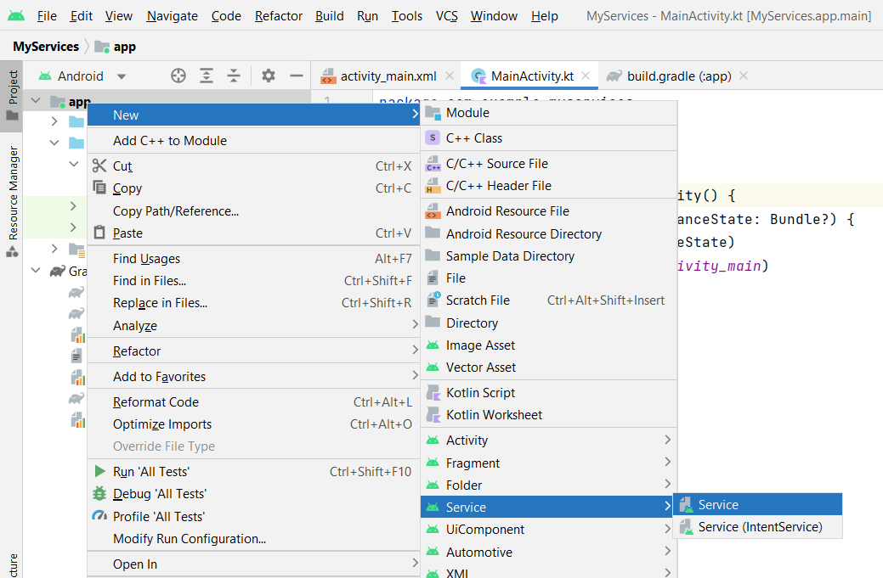

**Code:**

**activity_main.xml**

<?xml version="1.0" encoding="utf-8"?>  
<androidx.constraintlayout.widget.ConstraintLayout xmlns:android="http://schemas.android.com/apk/res/android"  
 xmlns:app="http://schemas.android.com/apk/res-auto"  
 xmlns:tools="http://schemas.android.com/tools"  
 android:layout_width="match_parent"  
 android:layout_height="match_parent"  
 tools:context=".MainActivity">  
  
 <TextView  
 android:layout_width="wrap_content"  
 android:layout_height="wrap_content"  
 android:text="Hello World!"  
 app:layout_constraintBottom_toBottomOf="parent"  
 app:layout_constraintEnd_toEndOf="parent"  
 app:layout_constraintStart_toStartOf="parent"  
 app:layout_constraintTop_toTopOf="parent" />  
  
</androidx.constraintlayout.widget.ConstraintLayout>

**MainActivity.kt**

package com.example.myservices  
  
import android.content.Intent  
import androidx.appcompat.app.AppCompatActivity  
import android.os.Bundle  
  
class MainActivity : AppCompatActivity() {  
 override fun onCreate(savedInstanceState: Bundle?) {  
 super.onCreate(savedInstanceState)  
 setContentView(R.layout.activity_main)  
  
 var myservice=Intent(this,MyMusicService::class.java)  
 startService(myservice)  
 }  
}

**MyMusicService.kt**

package com.example.myservices  
  
import android.app.Service  
import android.content.Intent  
import android.media.MediaPlayer  
import android.os.IBinder  
import android.widget.Toast  
  
class MyMusicService : Service() {  
  
 override fun onBind(intent: Intent): IBinder {  
 TODO("Return the communication channel to the service.")  
 }  
  
 override fun onCreate() {  
 super.onCreate()  
 var mc:MediaPlayer= MediaPlayer.create(this,R.raw.newmusic)  
 mc.start()  
 }  
  
 override fun onDestroy() {  
 super.onDestroy()  
 Toast.makeText(applicationContext,"Service End",Toast.LENGTH_SHORT).show()  
 }  
}

**Output:**

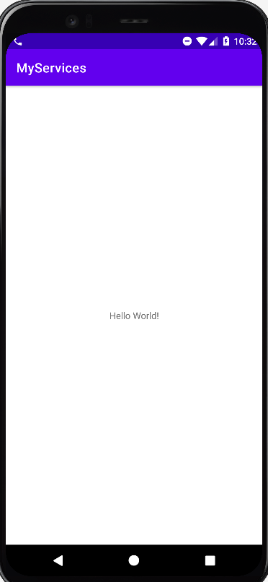 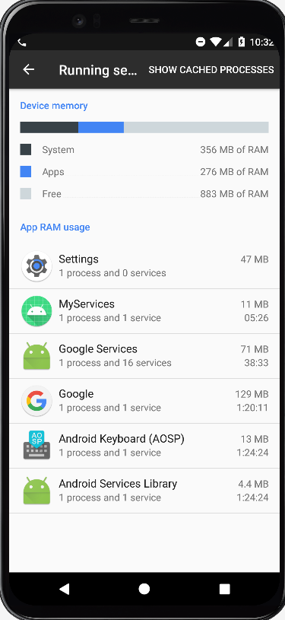

**Notification**

**Code:**

**activity_main.xml**

<?xml version="1.0" encoding="utf-8"?>  
<androidx.constraintlayout.widget.ConstraintLayout xmlns:android="http://schemas.android.com/apk/res/android"  
 xmlns:app="http://schemas.android.com/apk/res-auto"  
 xmlns:tools="http://schemas.android.com/tools"  
 android:layout_width="match_parent"  
 android:layout_height="match_parent"  
 tools:context=".MainActivity">  
  
 <Button  
 android:id="@+id/button"  
 android:layout_width="wrap_content"  
 android:layout_height="wrap_content"  
 android:text="Notification"  
 app:layout_constraintBottom_toBottomOf="parent"  
 app:layout_constraintEnd_toEndOf="parent"  
 app:layout_constraintHorizontal_bias="0.498"  
 app:layout_constraintStart_toStartOf="parent"  
 app:layout_constraintTop_toTopOf="parent"  
 app:layout_constraintVertical_bias="0.143" />  
</androidx.constraintlayout.widget.ConstraintLayout>

**MainActivity.kt**

package com.example.notificationpract  
class MainActivity : AppCompatActivity() {  
 override fun onCreate(savedInstanceState: Bundle?) {  
 super.onCreate(savedInstanceState)  
 setContentView(R.layout.activity_main)  
  
 button.setOnClickListener {  
  
 var currentApp=Intent(this,MainActivity::class.java)  
 var pi=PendingIntent.getActivity(this,1,currentApp,PendingIntent.FLAG_IMMUTABLE)  
 var manager=applicationContext.getSystemService(Context.NOTIFICATION_SERVICE) as NotificationManager  
  
 if (Build.VERSION.SDK_INT >= Build.VERSION_CODES.O) {  
 var chan=NotificationChannel("TYITNOTI","Tyit Notification",NotificationManager.IMPORTANCE_HIGH)  
 chan.lightColor=Color.GREEN  
 chan.enableLights(true)  
 chan.enableVibration(true)  
  
 var myNotification=NotificationCompat.Builder(this,"TYITNOTI")  
 myNotification.setSmallIcon(R.drawable.ic_launcher_background)  
 myNotification.setContentTitle("TYIT 2025")  
 myNotification.setContentText("SRM College Kudal,Info tech.")  
 myNotification.setPriority(NotificationManager.IMPORTANCE_HIGH)  
 myNotification.setAutoCancel(true)  
 myNotification.setContentIntent(pi)  
  
 manager.createNotificationChannel(chan)  
 manager.notify(1,myNotification.build())  
 }  
 else{  
 var myNotification=NotificationCompat.Builder(this,"TYITNOTI")  
 myNotification.setSmallIcon(R.drawable.ic_launcher_background)  
 myNotification.setContentTitle("TYIT 2025")  
 myNotification.setContentText("SRM College Kudal,Info tech.")  
 myNotification.setPriority(NotificationManager.IMPORTANCE_HIGH)  
 myNotification.setAutoCancel(true)  
 myNotification.setContentIntent(pi)  
  
 manager.notify(1,myNotification.build())  
 }  
 }  
 }  
}

**Output:**

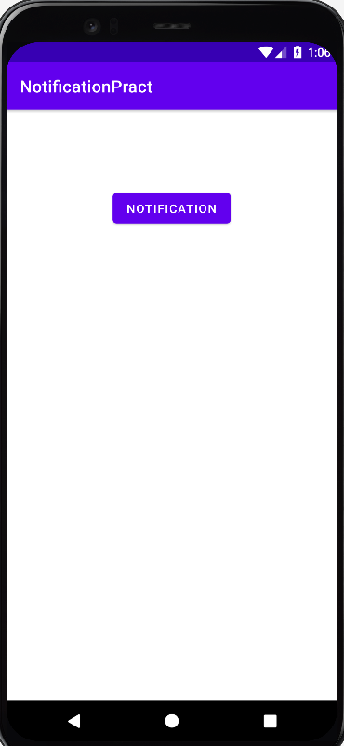 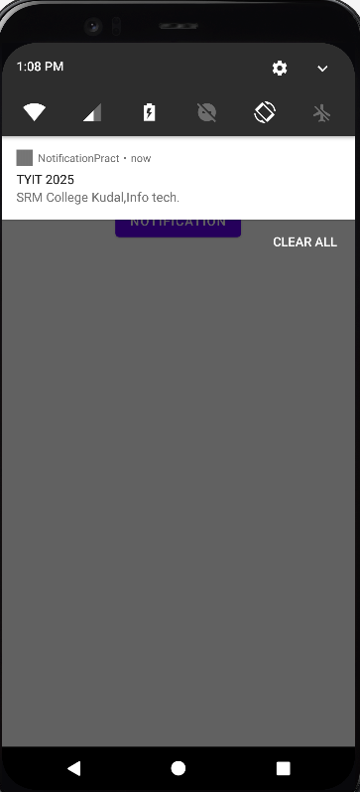

**Broadcast receivers**

**Code:**

**activity_main.xml**

<?xml version="1.0" encoding="utf-8"?>  
<androidx.constraintlayout.widget.ConstraintLayout xmlns:android="http://schemas.android.com/apk/res/android"  
 xmlns:app="http://schemas.android.com/apk/res-auto"  
 xmlns:tools="http://schemas.android.com/tools"  
 android:layout_width="match_parent"  
 android:layout_height="match_parent"  
 tools:context=".MainActivity">  
  
 <TextView  
 android:layout_width="wrap_content"  
 android:layout_height="wrap_content"  
 android:text="Hello World!"  
 app:layout_constraintBottom_toBottomOf="parent"  
 app:layout_constraintEnd_toEndOf="parent"  
 app:layout_constraintStart_toStartOf="parent"  
 app:layout_constraintTop_toTopOf="parent" />  
  
</androidx.constraintlayout.widget.ConstraintLayout>

**MainActivity.kt**

package com.example.broadcastpract  
  
import android.content.Intent  
import android.content.IntentFilter  
import androidx.appcompat.app.AppCompatActivity  
import android.os.Bundle  
  
class MainActivity : AppCompatActivity() {  
 lateinit var modeChecker:Checker  
 override fun onCreate(savedInstanceState: Bundle?) {  
 super.onCreate(savedInstanceState)  
 setContentView(R.layout.activity_main)  
  
 modeChecker= Checker()  
 IntentFilter(Intent.ACTION_AIRPLANE_MODE_CHANGED).also { registerReceiver(modeChecker,it) }  
 }  
}

**Checker.kt**

package com.example.broadcastpract  
  
import android.content.BroadcastReceiver  
import android.content.Context  
import android.content.Intent  
import android.widget.Toast  
  
class Checker:BroadcastReceiver() {  
 override fun onReceive(p0: Context?, p1: Intent?) {  
 var checkStatus=p1?.getBooleanExtra("state",false)?:return  
 if (checkStatus){  
 Toast.makeText(p0,"Airplane mode Enable",Toast.LENGTH_SHORT).show()  
 }  
 else{  
 Toast.makeText(p0,"Airplane mode Disable",Toast.LENGTH_SHORT).show()  
 }  
 }  
}

**Output:**

